**08 Jan 2020**

**RUNS WITH ZR_293K.SX**

Rand500.tex

🡪 tex_ph1.out after ipc15.1

Zr_bar.tex

🡪 tex_ph1.out after TTC15.3

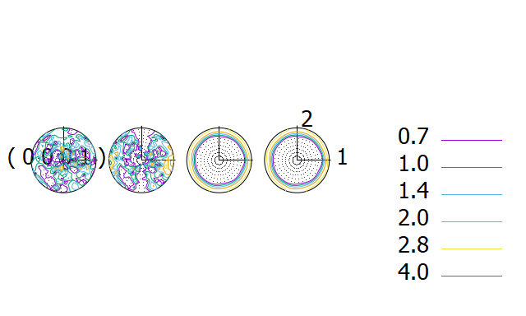

**RUNS WITH ZR_76K.SX**

Rand500.tex

🡪 tex_ph1.out after ipc15.1

Zr_bar.tex

🡪 tex_ph1.out after TTC15.3

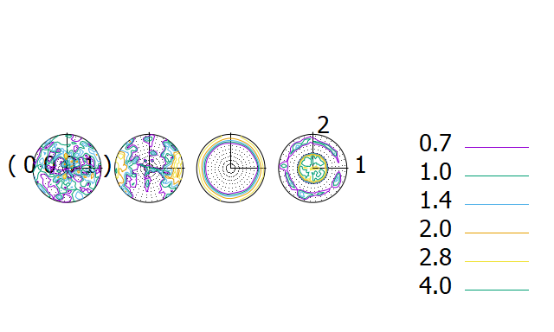

Zr bar texture

